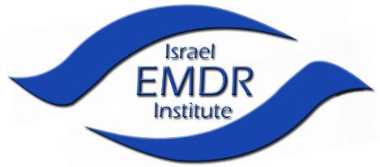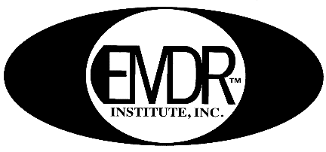
The Israel EMDR Institute The EMDR Institute, Inc.

EMDR Training in English-zoom
taught by Dr. Gary Quinn

EMDR therapy is recognized worldwide as an effective form of trauma treatment.

EMDR is a comprehensive, integrative psychotherapy that addresses the experiential contributors of a wide range of pathologies. It attends to the past experiences that have set the groundwork for pathology, the current situations that trigger dysfunctional emotions, beliefs and sensations, and the positive experience needed to enhance future adaptive behaviors and mental health.
EMDR has a broad base of published case reports and controlled research that supports it as an empirically validated treatment of trauma, and it has been found to be effective in Anxiety Disorders, Depressive Disorders, and many other disorders.

This training course is open only to
mental health professionals.
Dr. Gary Quinn is a well-known psychiatrist who was personally trained and certified by Dr. Francine Shapiro, the developer of EMDR. He is a Trainer of Trainers for the EMDR Institute (USA) in Asia as well as an Accredited EMDR-Europe Trainer. Dr. Quinn is the Director of The Israel EMDR Institute – www.emdr-israel.org. He has developed 2 unique stabilization techniques that are used world-wide: ISP® Immediate Stabilization Procedure after man-made, natural disasters in trauma. SCP-C Self Care Procedure for Coronavirus for future anxieties and fears.

The EMDR training course consists of lectures, demonstrations, and video tapes. There is also a large interactive component where each clinician participates in a small supervised group in the role of both therapist and client.

When: Part One – April 25,26,27,2021
Consultation groups May 11, 25 2021 / June 8 2021
Part Two​ – June 20,21,22, 2021
Consultation groups July 6,30 2021 / August 3 2021

Time: Course:9:00 am until 6:00 pm
Consultation groups 09:00-11:00
Location: ZOOM
Cost: for parts 1 & 2 6,000 nis
includes 8 hours group consultation per part and a manual.

Registration fee 500 nis

For more information or to register, please call (052)503-0877 Iris
or email: israel.emdr.institute@gmail.com

